Unexpected Threatened Species Finds Procedure
- Purpose
This procedure details the actions to be taken when a threatened flora or fauna species is unexpectedly encountered on site.
- Induction/Training
All workers are to be inducted on the potential threatened species occurring on site and the unexpected threatened species finds procedure during the site specific induction.
- Scope
This procedure is applicable to all activities that have the potential impact upon threatened flora and fauna species.
- Procedure
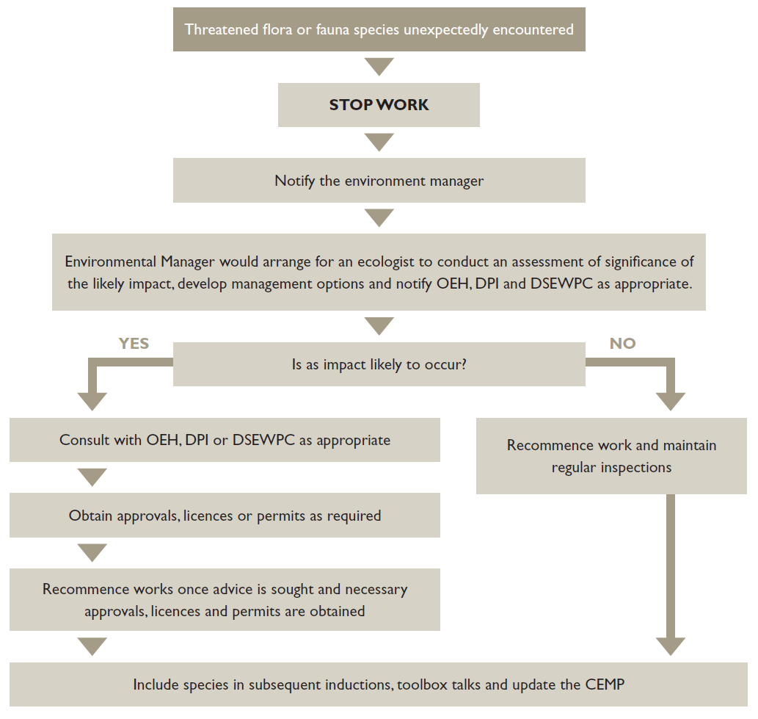
(TfNSW)

*Procedure adapted from Biodiversity Guidelines: Protecting and managing biodiversity on TfNSW projects Revision 0/September 2011

